for loop
for loop is used to iterate the values of collections or iterables.

Syntax:
for variable-name in iterable/collection:
statement-1
statement-2

for loop each time read value generated by iterable or collection and assign to variable. After assigning to variable it execute statement-1,statement-2.

For loop repeats statement-1,statement-2 until read all the values generated by iterable.

Example:  A=[10,20,30,40,50]  for x in A:  print(x,end=' ')  print()  for y in A[::-1]:  print(y,end=' ')  print()  for z in A[:3]:  print(z,end=' ')  print()  for p in A[2:]:  print(p,end=' ') | Output  10 20 30 40 50  50 40 30 20 10  10 20 30  30 40 50
Example  # Write a program to count +ve,-ve and zero's  A=[10,20,-30,-40,0,0,50,-60,-70,-80,100,200,0,-10,-20]  pc=0  nc=0  zc=0  for value in A:  if value>0:  pc=pc+1  elif value<0:  nc=nc+1  else:  zc=zc+1  print(f'List is {A}')  print(f'+ve values count {pc}')  print(f'-ve values count {nc}')  print(f'zero values count {zc}') | Output  List is [10, 20, -30, -40, 0, 0, 50, -60, -70, -80, 100, 200, 0, -10, -20]  +ve values count 5  -ve values count 7  zero values count 3
# Write a program to find maximum value in given list  A=[10,50,80,40,30,60,70]  max_value=A[0]  for value in A:  if value>max_value:  max_value=value  print(f'List is {A}')  print(f'Maximum value {max_value}') | Output  List is [10, 50, 80, 40, 30, 60, 70]  Maximum value 80
Example:  # Write a program to find minimum value in given list  A=[10,50,80,40,30,60,70,5,100,25,-5,8,9]  min_value=A[0]  for value in A:  if value<min_value:  min_value=value  print(f'List is {A}')  print(f'Minimum value {min_value}') | Output  List is [10, 50, 80, 40, 30, 60, 70, 5, 100, 25, -5, 8, 9]  Minimum value -5

iter() function (OR) iterator
The content of sequence can be read using iterator object.

How to create iterator object?
Iterator object is created using iter() function

Syntax: iter(iterable)

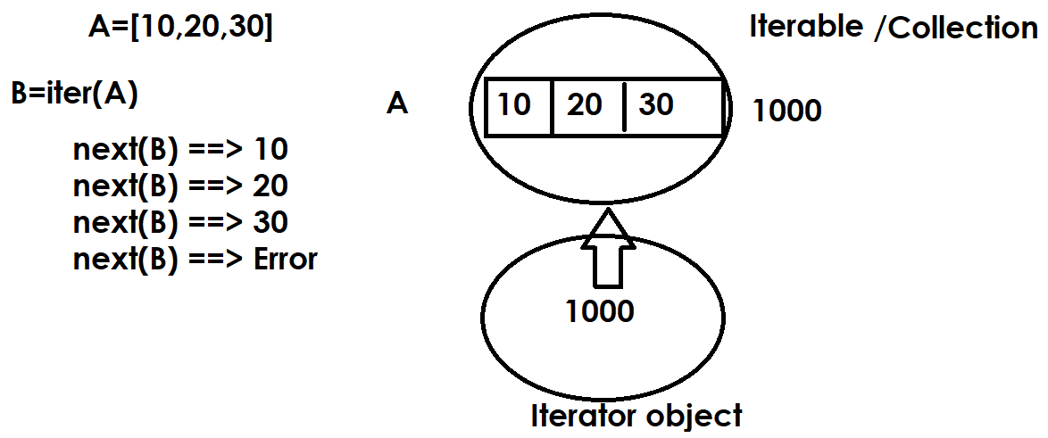
Example:  A=[100,200,300,400,500]  x=iter(A)  value1=next(x)  value2=next(x)  value3=next(x)  value4=next(x)  value5=next(x)  print(value1,value2,value3,value4,value5)  y=iter(A)  for value in y:  print(value,end=' ') | Output  100 200 300 400 500  100 200 300 400 500

enumerate(iterable, start=0)
Return an enumerate object. iterable must be a sequence, an iterator, or some other object which supports iteration.
enumerate() returns a tuple containing a count (from start which defaults to 0) and the values obtained from iterating over iterable.

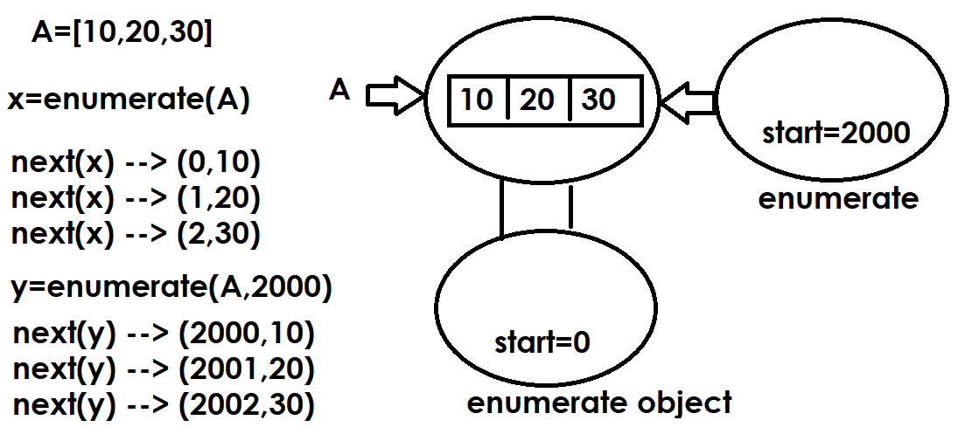

Example:  sales=[10000,20000,30000,40000,50000]  e=enumerate(sales,2010)  for x in e:  print(x) | Output  (2010, 10000)  (2011, 20000)  (2012, 30000)  (2013, 40000)  (2014, 50000)

Mutable Operations of list
After creating list changes can be done within list using mutable operations/methods provided by list.

append()
This method is used to add or append an element at end of list.

Syntax: list-name.append(element/object)

Example:
>>> A=[]
>>> print(A)
[]
>>> A.append(10)
>>> A.append(20)
>>> A.append(30)
>>> print(A)
[10, 20, 30]
>>> A.append(40)
>>> print(A)
[10, 20, 30, 40]
>>> id(A)
2373514598720
>>> A.append(50)
>>> print(A)
[10, 20, 30, 40, 50]
>>> id(A)
2373514598720
>>> A.append(100,200)
Traceback (most recent call last):
File "<pyshell#12>", line 1, in <module>
A.append(100,200)
TypeError: list.append() takes exactly one argument (2 given)

Example:
# Write a program to add n values into list and display

A=[]
n=int(input("How many values?"))

for _ in range(n):
value=int(input("Enter value "))
A.append(value)

print(f'List is {A}')

Output
How many values?3
Enter value 100
Enter value 200
Enter value 300
List is [100, 200, 300]

Example:
# Write a program to read name and n subject marks
# find total marks,avg marks
name=input("StudentName :")
n=int(input("How many subject Marks?"))
marks=[]

for i in range(n):
s=int(input(f'Subject{i+1}Marks:'))
marks.append(s)

print(f'StudentName {name}')
print(f'Marks {marks}')
total_marks=0
for value in marks:
total_marks=total_marks+value

print(f'Total Marks {total_marks}')
avg_marks=total_marks/n
print(f'Avg Marks {avg_marks}')

Output
StudentName :Naresh
How many subject Marks?3
Subject1Marks:60
Subject2Marks:70
Subject3Marks:80
StudentName Naresh
Marks [60, 70, 80]
Total Marks 210
Avg Marks 70.0

Example:
# Write a program to separate even and odd numbers
# from the following list

A=[1,7,9,12,67,3,54,13,31,22,25,56,89,98,77,65,64,82,21]
B=[]
C=[]

for value in A:
if value%2==0:
B.append(value)
else:
C.append(value)

print(f'List is {A}')
print(f'Even List is {B}')
print(f'Odd List is {C}')

Output
List is [1, 7, 9, 12, 67, 3, 54, 13, 31, 22, 25, 56, 89, 98, 77, 65, 64, 82, 21]
Even List is [12, 54, 22, 56, 98, 64, 82]
Odd List is [1, 7, 9, 67, 3, 13, 31, 25, 89, 77, 65, 21]

Example:
A=[1,2,3,4,1.5,2.5,"naresh","suresh",1+2j]
B=[]
C=[]
for value in A:
if isinstance(value,(int,)):
B.append(value)
elif isinstance(value,(str,)):
C.append(value)

print(A)
print(B)
print(C)

Output
[1, 2, 3, 4, 1.5, 2.5, 'naresh', 'suresh', (1+2j)]
[1, 2, 3, 4]
['naresh', 'suresh']

extend() function
This function of list allows appending more than one value

Syntax: list-name.extend(iterable)

>>> A=[10,20,30]
>>> print(A)
[10, 20, 30]
>>> A.extend([40,50])
>>> print(A)
[10, 20, 30, 40, 50]
>>> A.extend(range(60,110,10))
>>> print(A)
[10, 20, 30, 40, 50, 60, 70, 80, 90, 100]
>>> A.extend("PYTHON")
>>> print(A)
[10, 20, 30, 40, 50, 60, 70, 80, 90, 100, 'P', 'Y', 'T', 'H', 'O', 'N']
A.extend(55,66)
Traceback (most recent call last):
File "<pyshell#21>", line 1, in <module>
A.extend(55,66)
TypeError: list.extend() takes exactly one argument (2 given)
>>> A.extend([55,66])
>>> print(A)
[10, 20, 30, 40, 50, 60, 70, 80, 90, 100, 'P', 'Y', 'T', 'H', 'O', 'N', 55, 66]

What is difference between append() and extend()?
append method is able add only one object
extend method is able add more than one object

